**Prep for the Official Report for ADTA5250**

**By Group 12**

**🡪Audience:**

**🡪The Questions that need to be addressed in the dataset are:**

1. How do yearly arrest numbers vary in the dataset?
2. What are the most common types of charges in the dataset?
3. Are there discernible arrest patterns based on race, ethnicity, and gender?
4. Do specific days or times show higher arrest frequencies?

**🡪Dataset Information:**

🡪**Quality of Data:**

The "Crime Data at a Glance" dataset has various strengths in terms of data quality. For starters, it provides a full perspective of criminal episodes, including detailed information such as the type of charge, arrest date and time, and the severity of the offense. This degree of data enables in-depth examinations of crime trends and patterns. Furthermore, the inclusion of demographic information about the arrestees, such as color, ethnicity, and gender, allows for a more nuanced understanding of how different groups are affected by or participate in criminal activity.

The dataset also benefits from clear categorization of crimes, conforming to standards such as the National Incident-Based Reporting System (NIBRS), which improves its dependability and comparability with other datasets. The inclusion of political context, such as the names of the mayor and president, as well as their party affiliations at the time of each arrest, provides an interesting layer to studying crime statistics against the backdrop of political leadership.

Overall, the rich detail and organized nature of the dataset make it an excellent resource for evaluating crime patterns, identifying demographic consequences, and investigating the relationship between crime and political situations.

**Official Report for the City of Dallas Operating Budget**

The "Crime Data at a Glance" dataset is an important resource for advanced criminological study and policy analysis. It provides a comprehensive summary of criminal episodes, including arrest details, charge kinds, and demographic data. This extensive dataset allows graduate-level experts to decipher intricate patterns in criminal behavior and law enforcement while also providing light on broader socioeconomic and political undercurrents. It is an essential resource for understanding the complexities of crime and justice in contemporary society.

**🡪The Questions that are addressed in this report are:-**

1. What does the trend in the heat map indicate about the distribution of crime across days of the week over the years?

2. How do the bar graphs correlate top charge types with arrest counts, and what does this reveal about crime prevalence?

3. What inference can be made from the line graph about the change in the number of total arrests over time?

4. How does filtering the data by race and gender affect the distribution of arrest types and frequencies?

**1)**

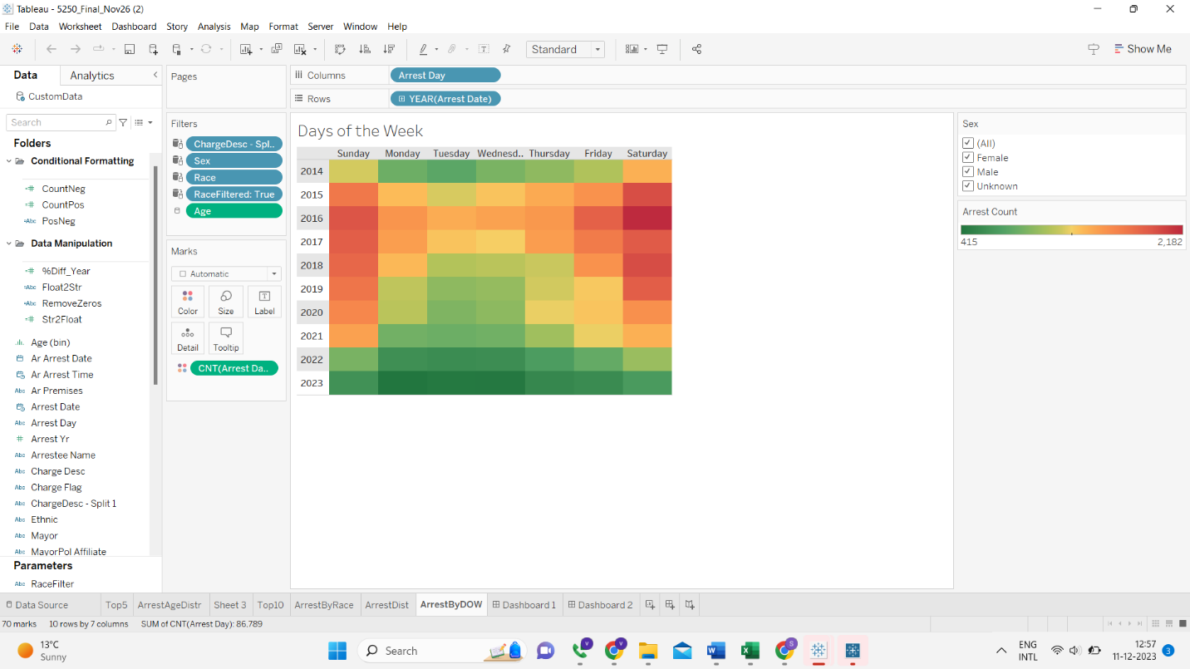

**Business Insights:**

1. The heat map shows a distinct pattern, with arrest counts varied by weekday and year. The concentration of colors shows that particular days may consistently have higher arrest rates, which could influence law enforcement agencies' personnel and patrol scheduling.
2. The data appears to demonstrate a temporal shift or change in the number of arrests over time. These trends can help influence community policing strategic planning and may show the effectiveness of crime prevention initiatives over time.
3. While the gender filter is visible, insights on the gender breakdown of arrests are not visible in the present view. However, if this data is accessible and indicates that there are significant differences in arrest patterns by gender, it could be critical for designing gender-specific community outreach or support programs.
4. The granularity of the data, with arrests broken down by day and year, might be used to maximize law enforcement resource allocation and budgeting. Understanding when resources are most needed can lead to more efficient use of finances and manpower.

**Unexpected Findings:**

1. The line graph demonstrates an erratic pattern in arrest rates over time, which contradicts the expected constant trend and may imply policy influence or reporting standards shifts.
2. The heat map indicates surprising surges in arrests on specific midweek days, calling into question the widely held idea that most arrests occur on weekends due to increased social activities..

2) **:**

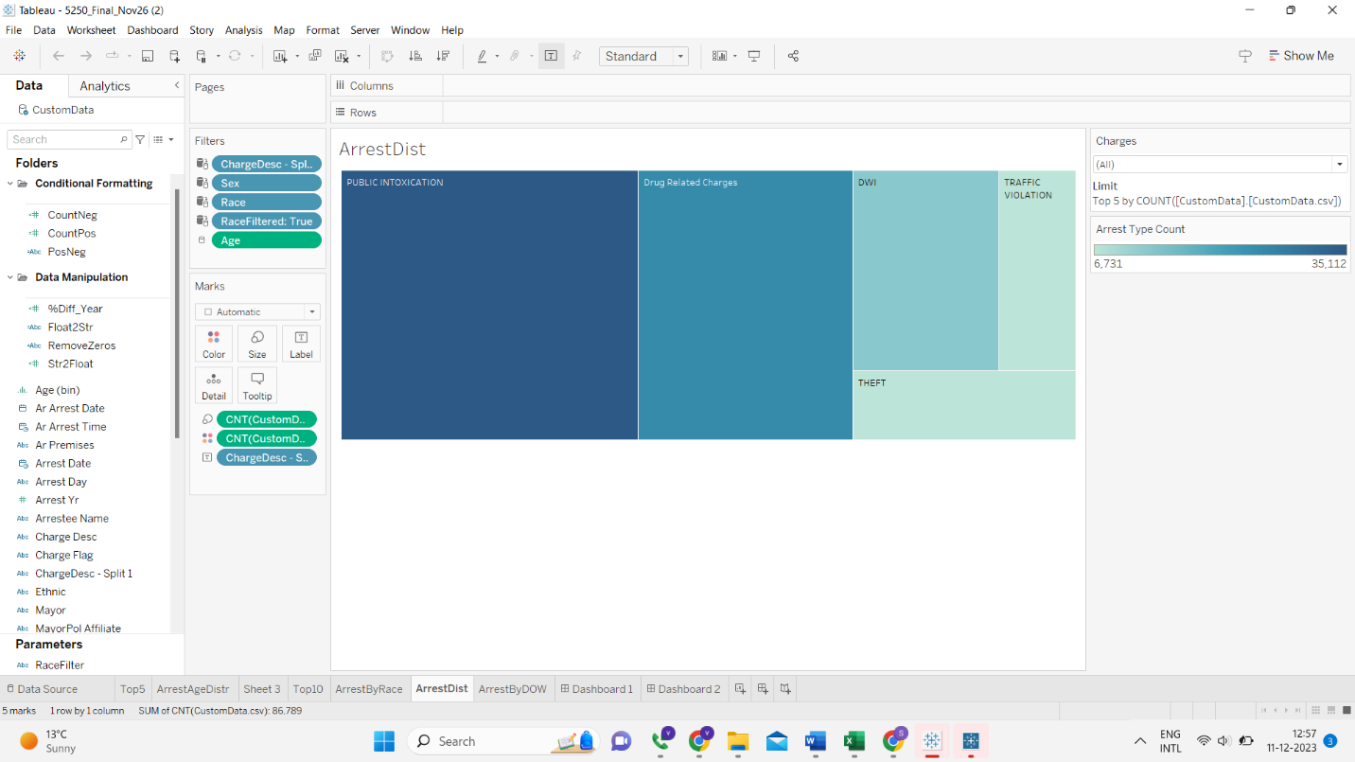

**Business Insights:**

1. The table divides arrests into categories such as "Public Intoxication," "Drug Related Charges," "DWI," "Theft," and "Traffic Violation," demonstrating the most common causes of arrest. This highlights a focus for law enforcement training and community prevention efforts.
2. The size of the bars represents the number of arrests for each charge type. The terms "traffic violation" and "theft" appear to be the most common, indicating that these are important areas for crime reduction initiatives.
3. Law enforcement organizations might utilize this data to more effectively allocate resources by focusing on the most common types of crime.
4. Tracking variations in the frequency of certain arrest types over time could aid in determining the effectiveness of new laws or efforts aimed at lowering specific crimes.

**Unexpected Findings:**

1. Given the prevalent emphasis on DUI/DWI prevention and enforcement in public safety campaigns, DWIs may not account for as significant a proportion of arrests as one might think.
2. There could be an unanticipated balance between drug-related charges and arrests for public intoxication, which could reflect local law enforcement priorities or cultural behavior patterns.
3. It may come as a surprise if theft and traffic violations occur at comparable rates, because stealing is frequently seen as a more planned crime than what may be considered trivial driving violations.

**3)**

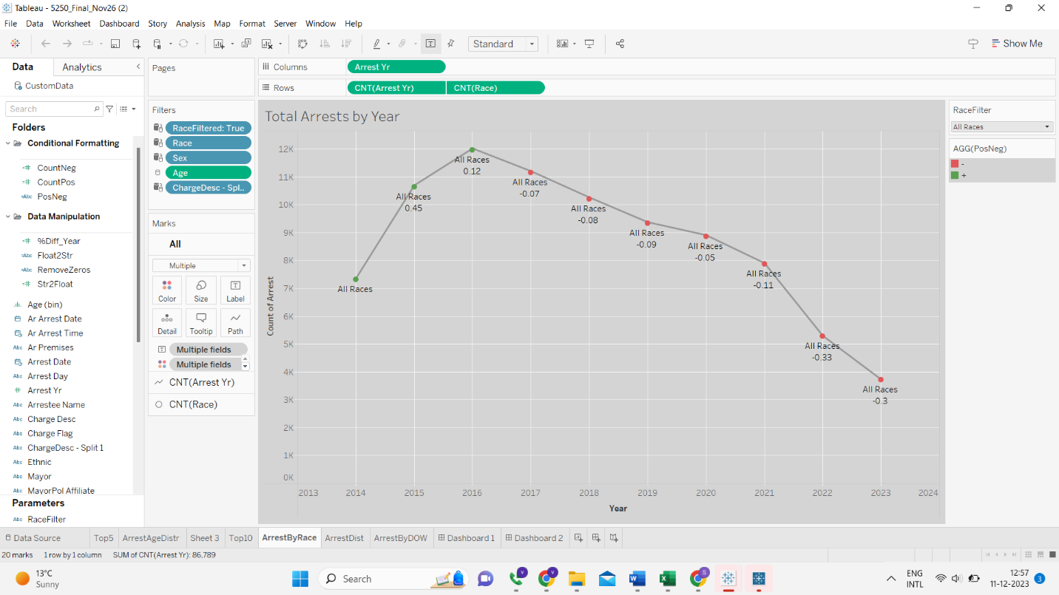

**Business Insights:**

1. Total arrests have been decreasing over the years, which could indicate improvements in community safety, the effectiveness of preventive measures, or changes in law enforcement reporting.
2. Policymakers and law enforcement organizations can use trend data to analyze the impact of their initiatives and make data-driven decisions.
3. The decrease in arrests may have an effect on the allocation of resources and funds for law enforcement, indicating a prospective move toward community programming.
4. Law enforcement organizations may be able to take advantage of this trend to increase operational efficiency by reallocating resources to areas with more need or focusing more on rehabilitation and education activities.

**Unexpected Findings:**

1) The drop in arrests appears to be persistent and considerable, which is surprising given that population growth or economic downturns frequently result in greater crime rates.

2) The comments (for example, "All Races 0.12") indicate that there may be yearly variation in arrest rates that does not precisely follow a linear trend, revealing underlying causes influencing arrest numbers.

3) The term "All Races" implies that the trend is consistent across different racial groupings, which may be surprising given the discrepancies in arrest numbers that are frequently evident.

**Dashboard Screenshot:**

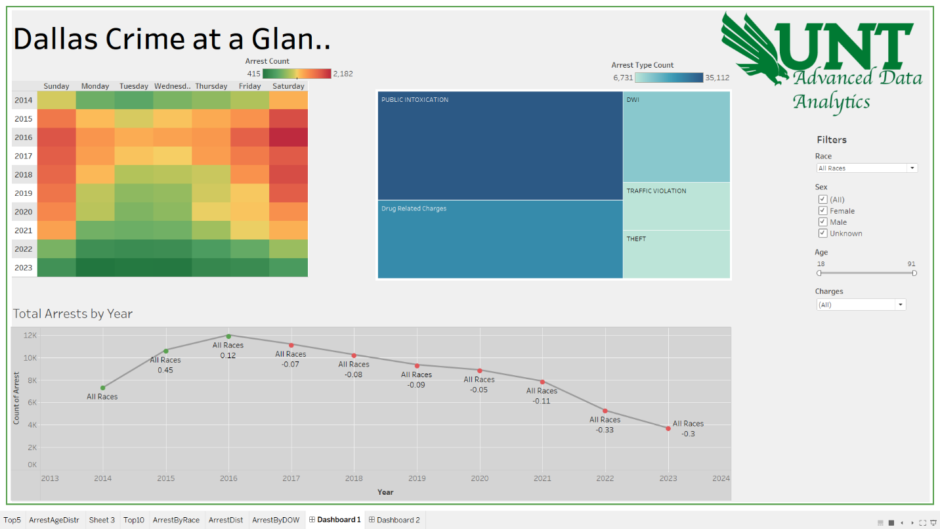

**Recommendations:**

1. To emphasize the severity of arrest counts, the heatmap for "Arrest Count" by day of the week and year may benefit from a sharper color gradient or labeling.
2. The "Arrest Type Count" bar chart presently displays absolute figures. Incorporating percentage figures could provide a clearer picture of the proportion of each arrest type that contributes to the total.
3. The annotations on the line graph "Total Arrests by Year" are useful, however they may be improved with tooltips that provide extra explanation when clicked over.
4. The filters section comprises "Race," "Sex," "Age," and "Charges," all of which are required for in-depth investigation. However, adding a reset or clear-all option to these filters would improve user navigation and convenience of use.
5. A feature that allows users to export filtered data or selected chart data for external analysis or reporting may be useful to them.
6. Drill-down options that reveal more detailed information by clicking on a specific data point would make the dashboard more engaging**.**

**Appendix:**

|  |  |
| --- | --- |
| **Team Member Name** | **Participation in doing Report** |
| Young Yu, SharikhIrfaan | Together discussed and wrote the Prep for the Official report jointly. |
| Young Yu, SharikhIrfaan | Together provided the business insights and unanticipated findings. |
| Young Yu, SharikhIrfaan | Together provided business insights as well as unexpected findings for 3rd chart. |
| Young Yu, SharikhIrfaan | Together provided business insights as well as unexpected findings for 3rd chart. |
| Young Yu, SharikhIrfaan | Finally reviewed the full document and formatting before uploading. |